Title: Lifespan inequality in Denmark, Sweden and Norway: the inter-war female generations

Authors: José Manuel Aburto ^{a*}, Maarten Wensink ^{a*}, James W. Vaupel ^{a,} & Rune Lindahl-Jacobsen ª
Author affiliations:
ª Max-Planck Odense Center on the Biodemography of Aging, Department of Public Health- Epidemiology, Biostatistics and Biodemography, University of Southern Denmark, Odense 5000, Denmark.

* These authors contributed equally to the paper

Corresponding authors: José Manuel Aburto & Maarten Wensink

Classification: Social Sciences, Public Health – Demography

Keywords: Demography, life expectancy, lifespan variability, aging, mortality.

Abstract [250 words]
Background
Methods
Results
Conclusions

Introduction [aimed to IJE] [3000 words]
Female life expectancy in Denmark has followed an atypical pattern in the second half of the 20th century. While their Scandinavian counterparts showed continuous improvement, life expectancy stagnated among Danish women between the late-1970s and mid-1990s, to improve thereafter (1-3), while remaining lower than in Sweden and Norway (3). The stagnation of life expectancy and its current lower level resulted mainly from increased mortality of those born between the two World Wars (3), among which smoking was more prevalent (1, 2).
Life expectancy is commonly used to measure the overall health status of a population. However, life expectancy conceals disparities in individual mortality trajectories (4), known as lifespan inequality. Inequality in lifespans refers to the variation in age at death in a population, and it expresses a fundamental difference among individuals (5). It has become relevant for policy makers with the growing interest in reducing health inequalities (6), and it has been found negatively associated with life expectancy (7). Therefore, studying lifespan inequality alongside life expectancy adds an important dimension to the study of population health because both indicators complement individuals’ decisions. For instance, individuals may decide when to invest in education or when to retire based in their expected longevity, but also in the uncertainty surrounding their eventual time of death (8). This is particularly relevant for countries that have experienced a relative low level of life expectancy and a slow progress in reducing premature mortality like Denmark compared to other countries in the region such as Norway and Sweden. We thus hypothesize that the Danish population may be experiencing increases in lifespan inequality while improvements in life expectancy were slowed down. We also expect lower inequality in Norway and Sweden, and anticipate a detrimental effect on the Danish female population due to the higher mortality experienced by the inter-war generations.
This paper makes three main contributions. Firstly, it contributes to the literature on health inequalities in the context of a developed country with a relative low life expectancy. Most studies in this area focus on the progress made in life expectancy alongside reductions in lifespan inequalities. In contrast, our paper highlights the role of mortality of females that belong to the inter-war generations during life expectancy stagnation. Secondly, we analyze the contributions of smoking-related mortality to changes in lifespan inequality over the last half century. The changing in the epidemiological profile of Denmark, Sweden and Norway in the last century underscores the need of cause-of-death analysis in determining the best future public health interventions. Finally, this paper contributes to our knowledge of lifespan inequality in the Scandinavian region.

Data and Methods

We use publicly available period lifetables from the Human Mortality Database (9) for Denmark, Sweden and Norway from 1960 to 2014. These data contain high quality information on lifetable’s measures, such as the death distribution, survival function and life expectancy, by single age and sex. We use cause-of-death data from the WHO Database to compute the proportion of deaths by cause, age, and sex in a given year for the same period (10). To improve accuracy of our estimates, we ungrouped the cause-of-death data into single year ages using efficient estimation of smooth distributions and used the proportions in the single-age lifetables (11).
Cause-of-death classification
Data on causes of death was classified using the seventh, eighth, ninth and tenth revisions of the International Classification of Diseases (ICD) during the period studied. For instance, in Denmark revision 7 in 1960-1968, then revision 8 until 1994, followed by the 10th revision thereafter (12), while Sweden and Norway did include the 9th revision to code deaths in the periods 1987-96 and 1986-95, respectively. To merge cause-of-death we used previously suggested bridge codes (13).
Deaths were grouped in nine major cause-of-death categories aiming at better capturing conditions that might have affected mortality in these of countries, such as 1) Infectious (non-respiratory), 2) Cancers amenable to smoking, 3) Cancers non-amenable to smoking, 4) Diabetes, 5) Cardiovascular diseases, 6) Respiratory (infectious), 7) Respiratory (non-infectious), 8) External, and 9) Rest of causes. For ICD codes and details on the classification see SI Table 1.
Amenable to smoking conditions were classified following a recent review article and a WHO report (14). Respiratory diseases were partitioned as infectious versus non-infectious. Although smokers are more prone to respiratory infections than non-smokers, when suffering from COPD, deaths from infections of the respiratory tract also very much depend on the discovery of antibiotics and their application through researched protocols: the discovery of penicillin was not a one-off effect, but a development that has reached maturity only relatively recently. External causes are likely to have an important effect on young mortality that could affect lifespan inequality, in men particularly (15). Finally, we aimed to find the optimal resolution for the grouping of causes of death. A resolution that is too fine is likely to run into the limits of classifying and partitioning causes of death, especially when tracking these causes of death over a large amount of time, while a resolution that is too coarse may leave important information undiscovered (Masters et al. 2017). With our classification, we have struck a good balance between these considerations.
We focus on cause-specific mortality below age 85 for four reasons. First, we calculated that about 90% of the change in life expectancy from 1960 to 2014 was due to mortality changes below that age. Second, cause-of-death classification is less reliable at older ages (Kohn 1982, Gesser et al. 2002, Meslé and Vallin 2017). Third, the presence of several comorbities at ages above 84 could bias our results (Gesser et al. 2002, Meslé and Vallin 2017). Fourth, in the presence of several competing causes of death there exists a smaller, less significant, step from one cause to the other (Mackenbach et al. 1997).
Lifespan inequality measure
Several dispersion measures have been proposed to analyze lifespan inequality (16). Here, we use the coefficient of variation, which is the standard deviation divided by the mean of the lifetable age-at-death distribution, i.e. life expectancy (see SI for a brief description). This has been shown to be a good indicator to measure lifespan inequality (17). The strong correlation between lifespan inequality indicators suggests that main conclusions and results would not differ regardless of the which one is used (16, 18, 19).
Decomposition techniques
Lifespan inequality may increase or decrease while life expectancy is stagnating, depending on the balance between reducing mortality at early ages, which compresses lifespan inequality, and saving lives at older ages, which increases inequality in lifespans (20, 21). To get a better interpretation of the reasons behind changes in lifespan inequality over time, we decompose lifespan inequality differences before, during, and after the stagnation of life expectancy by age and causes of death using standard decomposition techniques (22).
  - Limitations

The limitations of the study should be mentioned. The potential of changing insights in disease processes to affect classification. For instance, pneumonia may be increasingly classified as secondary cause of death. Similarly, a hip fracture may lead to immobilization and hospitalization, which increases the chance of getting pneumonia. As awareness of hospital acquired pneumonia increased, pneumonia got increasingly classified as secondary, not primary cause of death. The interaction of causes is a basic reality (Rothman 1976).
Despite these limitations, a cause of death classification can be useful in highlighting those aspects that one is interested in. Regardless of what drives the decline in respiratory infections as a cause of death, our partitioning of respiratory death in infectious versus non-infectious is likely to be robust. Moreover, to mitigate major changes due to the difference in coding, we focus on five broad causes of death and performed a sensitivity analysis and did not find major ruptures using our classification (see SI).

  - Preliminary results

Trends in lifespan inequality and life expectancy
Figure 1 shows trends in life expectancy (Panel A) and lifespan equality (Panel B) from 1960 to 2015 for Denmark, Norway and Sweden. Life expectancy has been increasing continuously in the last 50 years in Norway and Sweden, in both females and males. Danish women show a period of stagnation between 1980 and the mid-1990s, while males show a slow progress. Paralleling the rise in life expectancy, lifespan inequality has continuously fall. In every country females experience less inequality in lifespan than males. As oppose to life expectancy, lifespan inequality has continued to decrease, even in the periods of life expectancy stagnation in Denmark. It is worth noting that, although Sweden and Norway show similar levels in lifespan inequality. Sweden is the country experiencing the highest life expectancy and lowest inequality in lifespans of this set of countries.

[Figure 1 about here]
Age-cause specific decomposition of lifespan inequality
Figure 2 shows age and cause-specific contributions to changes in lifespan inequality for three periods for Danish females from age 1. 1960-1975 relates to a period of improvements in life expectancy and lifespan inequality, 1975-1995 related to the stagnation in female life expectancy, and 1995-2014 to a period of recent progress in reducing mortality and rising life expectancy.
Between 1960 and 1975, reductions in lifespan inequality were mainly driven by reducing mortality from cardiovascular diseases below age 85. In the following 20 years, the slow progress and stagnation in lifespan inequality were driven by an offsetting effect of major improvements made in cardiovascular diseases and deterioration in cancers and respiratory non-infectious diseases. Finally, in the most recent period (1995-2014) lifespan inequality has decreased substantially because of improving mortality from cancers and cardiovascular diseases.
[Figure 2 about here]
Future work
We will get results for Sweden and Norway and make comparisons to quantify how much Denmark should reduce mortality from specific causes of death to converge towards the levels of lifespan inequality and expectancy that Sweden and Norway show. In addition, we will look for cohort effects in specific causes of death since it has been found previously that cohort process are major determinants in life expectancy trends in Denmark.

Figures and Tables
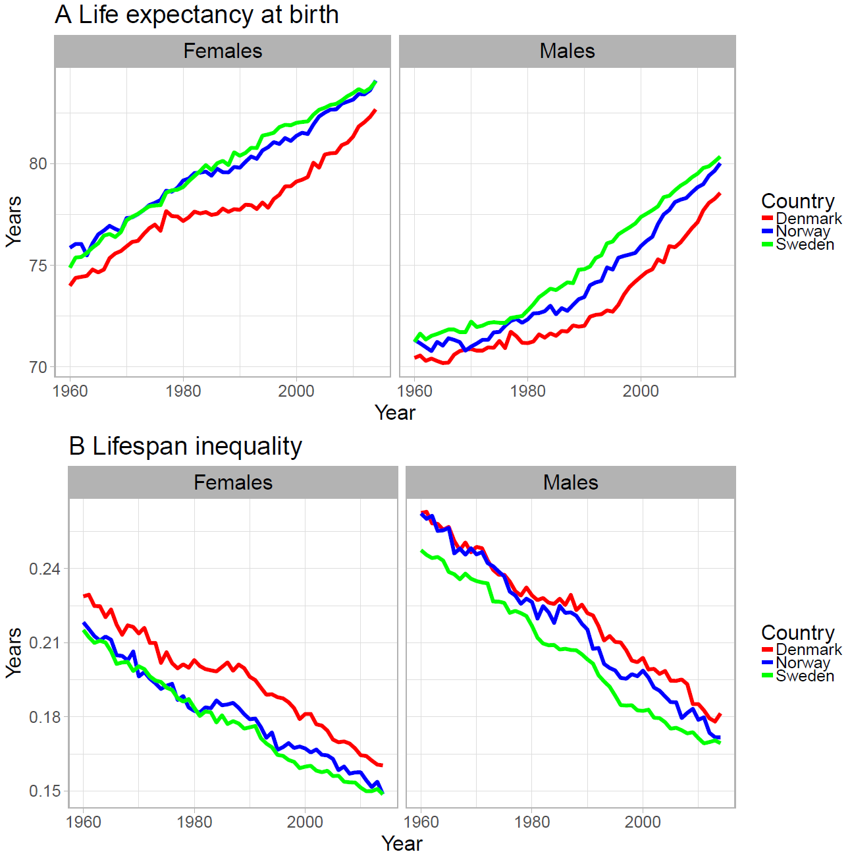
Figure 1. Life expectancy (panel A) and lifespan inequality (panel B) trends from 1960 to 2015 for Denmark, Sweden and Norway by sex.
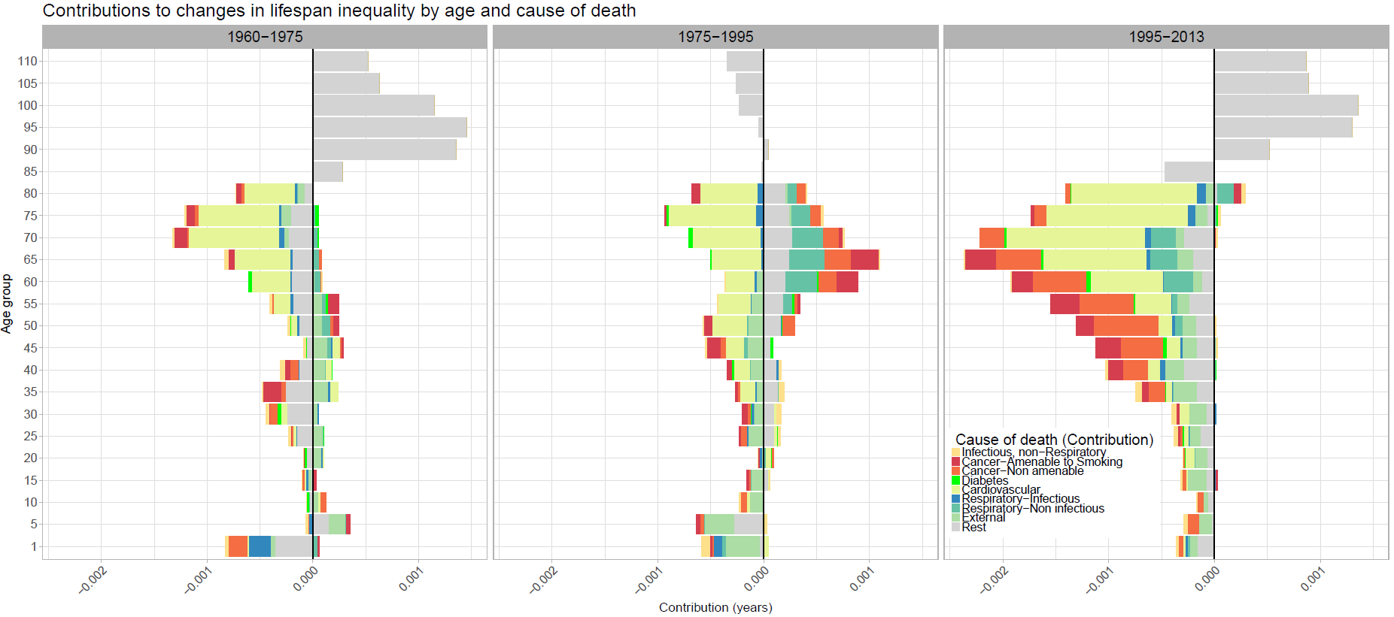
Figure 2. Age and cause contributions to changes in lifespan inequality between 1960-1975, 1975-1995 and 1995-2014 for Danish females.

References

1. Jacobsen R, Von Euler M, Osler M, Lynge E, Keiding N. Women's death in Scandinavia—what makes Denmark different? European journal of epidemiology. 2004;19(2):117-21.
2. Lindahl-Jacobsen R, Oeppen J, Rizzi S, Möller S, Zarulli V, Christensen K, et al. Why did Danish women’s life expectancy stagnate? The influence of interwar generations’ smoking behaviour. European Journal of Epidemiology. 2016:1-5.
3. Lindahl-Jacobsen R, Rau R, Jeune B, Canudas-Romo V, Lenart A, Christensen K, et al. Rise, stagnation, and rise of Danish women’s life expectancy. Proceedings of the National Academy of Sciences. 2016;113(15):4015-20.
4. Edwards RD, Tuljapurkar S. Inequality in life spans and a new perspective on mortality convergence across industrialized countries. Population and Development Review. 2005;31(4):645-74.
5. Tuljapurkar S. The final inequality: variance in age at death. Demography and the Economy: University of Chicago Press; 2010. p. 209-21.
6. Marmot M. Inequalities in health. New England Journal of Medicine. 2001;345(2):134-5.
7. Vaupel JW, Zhang Z, van Raalte AA. Life expectancy and disparity: an international comparison of life table data. BMJ open. 2011;1(1):e000128.
8. van Raalte AA, Kunst AE, Deboosere P, Leinsalu M, Lundberg O, Martikainen P, et al. More variation in lifespan in lower educated groups: evidence from 10 European countries. International Journal of Epidemiology. 2011:dyr146.
9. Human Mortality Database. University of California BU, and Max Planck Institute for Demographic Research (Germany). Human Mortality Database. 2017.
10. Organization WH. Health statistics and information systems 2017 [Available from: http://www.who.int/healthinfo/mortality_data/en/.
11. Rizzi S, Gampe J, Eilers PH. Efficient estimation of smooth distributions from coarsely grouped data. American journal of epidemiology. 2015;182(2):138-47.
12. Erlangsen A, Fedyszyn I. Danish nationwide registers for public health and health-related research. Scandinavian Journal of Social Medicine. 2015;43(4):333-9.
13. Janssen F, Kunst AE. ICD coding changes and discontinuities in trends in cause-specific mortality in six European countries, 1950-99. Bulletin of the World Health Organization. 2004;82(12):904-13.
14. Whiteman DC, Wilson LF. The fractions of cancer attributable to modifiable factors: A global review. Cancer epidemiology. 2016;44:203-21.
15. Helweg-Larsen K, Juel K. Sex differences in mortality in Denmark during half a century, 1943-92. Scandinavian Journal of Social Medicine. 2000;28(3):214-21.
16. van Raalte AA, Caswell H. Perturbation analysis of indices of lifespan variability. Demography. 2013;50(5):1615-40.
17. Wrycza TF, Missov TI, Baudisch A. Quantifying the shape of aging. PloS one. 2015;10(3):e0119163.
18. Wilmoth JR, Horiuchi S. Rectangularization revisited: Variability of age at death within human populations*. Demography. 1999;36(4):475-95.
19. Colchero F, Rau R, Jones OR, Barthold JA, Conde DA, Lenart A, et al. The emergence of longevous populations. Proceedings of the National Academy of Sciences. 2016.
20. Gillespie DO, Trotter MV, Tuljapurkar SD. Divergence in age patterns of mortality change drives international divergence in lifespan inequality. Demography. 2014;51(3):1003-17.
21. Zhang Z, Vaupel JW. The age separating early deaths from late deaths. Demographic Research. 2009;20(29):721-30.
22. Horiuchi S, Wilmoth JR, Pletcher SD. A decomposition method based on a model of continuous change. Demography. 2008;45(4):785-801.

